EXPERIMENT NO : 01

Aim: Explore usage of basic linux commands and system calls for files, directory and process management.

Theory:

1. who : it is used to find out the current user who is logged into the system.

2. pwd : present working directory, lets you know the current directory you are in.

3. cal : show the calendar of the complete month.

4. date : It shows you the current date, along with the time, along with the day, along with the year.

5. mkdir: to create a new directory under any directory

6. chdir/cd : to change the current working directory

7. cat : to create the file and display the contents of the file

8. chmod: to change the mode of the file. There are three modes read(r), write(w) and execute(e)

9. ls : to list all directories and subdirectories

a. ls-l : to show the long listing information about the directory

b. ls-lh : human readable format.

c. ls-ld : shows the details of the directory content.

d. ls-d* : to show the sub directories in a directory

e. ls-a : to show hidden files

f. ls-lhs : show files in the descending order in which you have used your files.

10. sort-r file name.txt : sorts the list in reverse order

11. sort-n file name.txt : its sorts the numerical list in ascending order

12. sort nr file name.txt : its sorts the numerical list in reverse order

13. sort u file name.txt : to remove the duplicates

14. sort m file name.txt : Sorts the months in ascending order

15. awk : it is used for the user that defines text patterns that are to be searched for each line of the file.

Syntax , awk '{print}' file name.txt

awk '/faculty/{print}' file name.txt :

awk '{print}NR, $0}' file name.txt :

NR - specifies the number of lines.

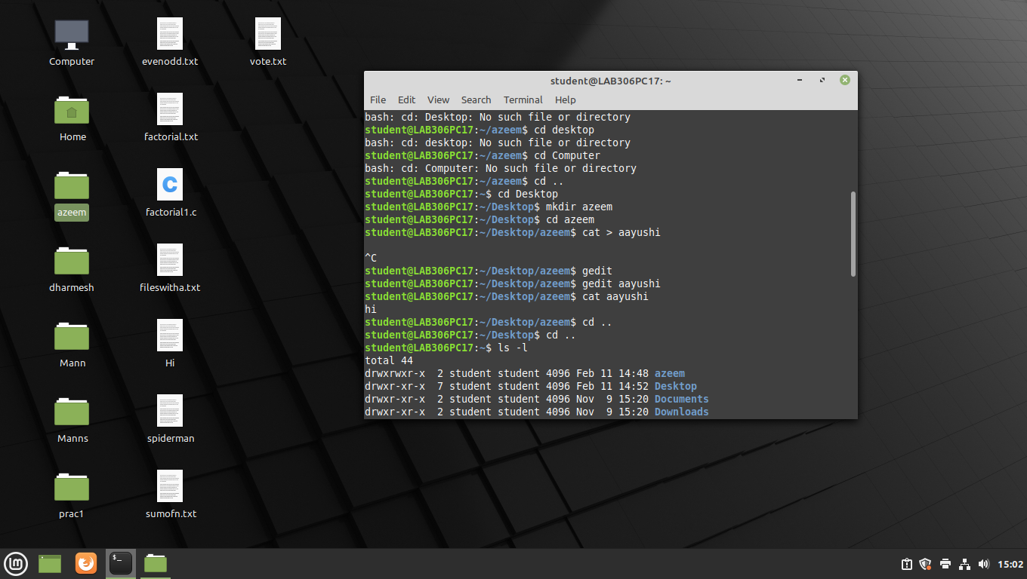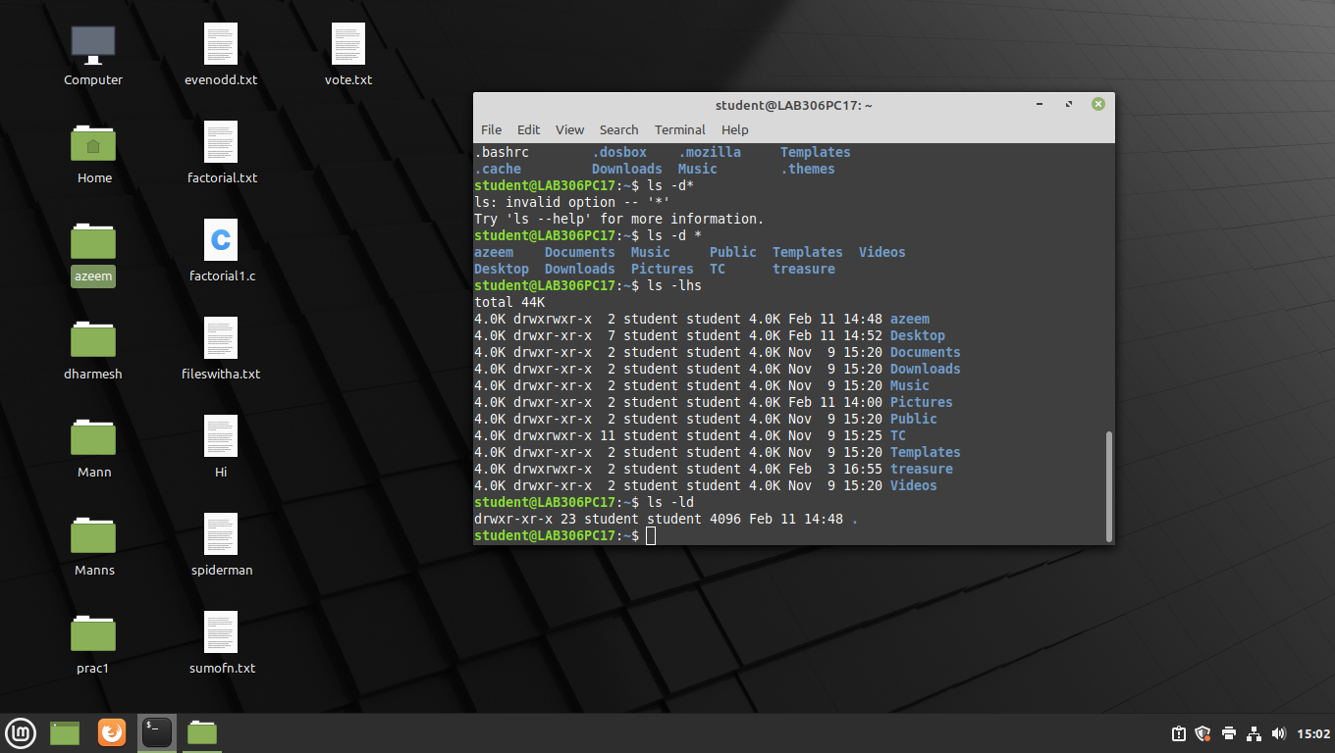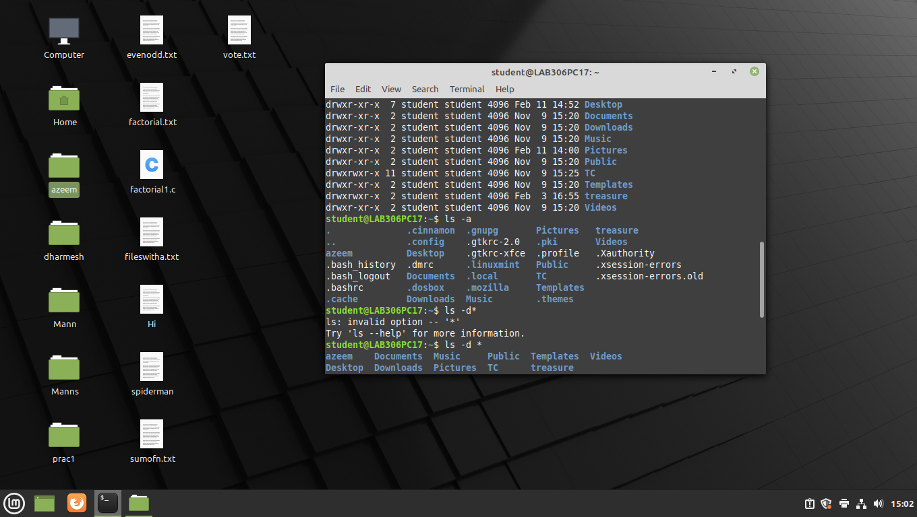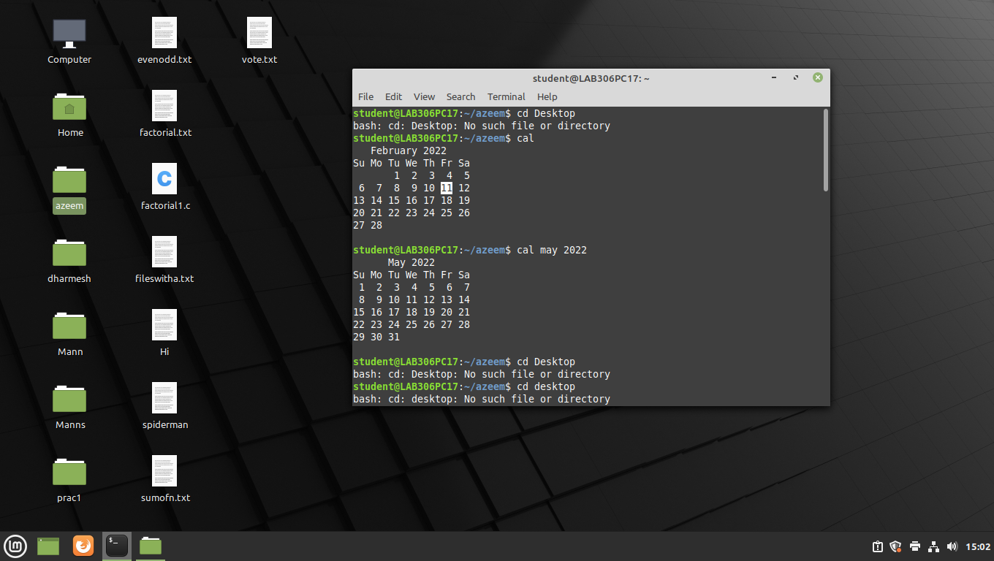

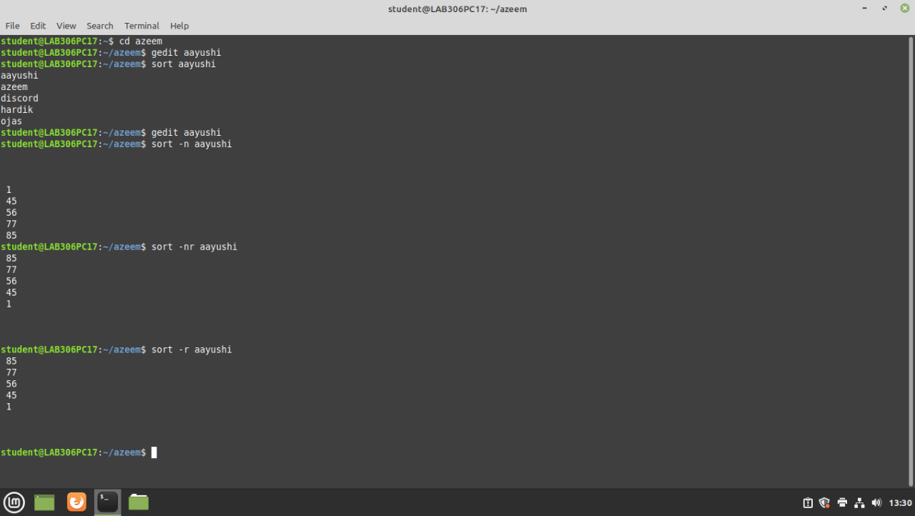

EXPERIMENT NO : 02

Aim : To study the shell scripting language

A display OS version release number kernel version

B display top 10 processors in descending order

C display processes with highest memory usage

D display c+

Theory :

A]

i) uname - r{username}

* To show the OS version, release no. OS release version

ii) uname - v

* Shows Kernel version (last when launched)

iii) uname - a

* Shows all the details including OS used, PC and other details.

us - c + u - r → us - a

B]

i) ps-aux (i) sort : nk +41 tail

* Sorts 10 processes in descending order. It shows logged in users, modes of memory & storage.

OR

ii) ps-aux | tail

* Same as above

OR

iii) ps-aux | sort -nl+4 | tail - n15 (shows top 15 processes)

* same with 15

C]

i) sudo apt install htop

* shows date of processes with highest memory

ii) ps - eo pid, ppid, cmd, % mem, % cpu –sort =-% mem | head

* same as above same as above

D]

i) ps-p$$

* Shows process ID and current shell

ii) echo display home directory

echo $ home

* To display home directory

Conclusion : Thus we have successfully studied and implemented shell scripting languages

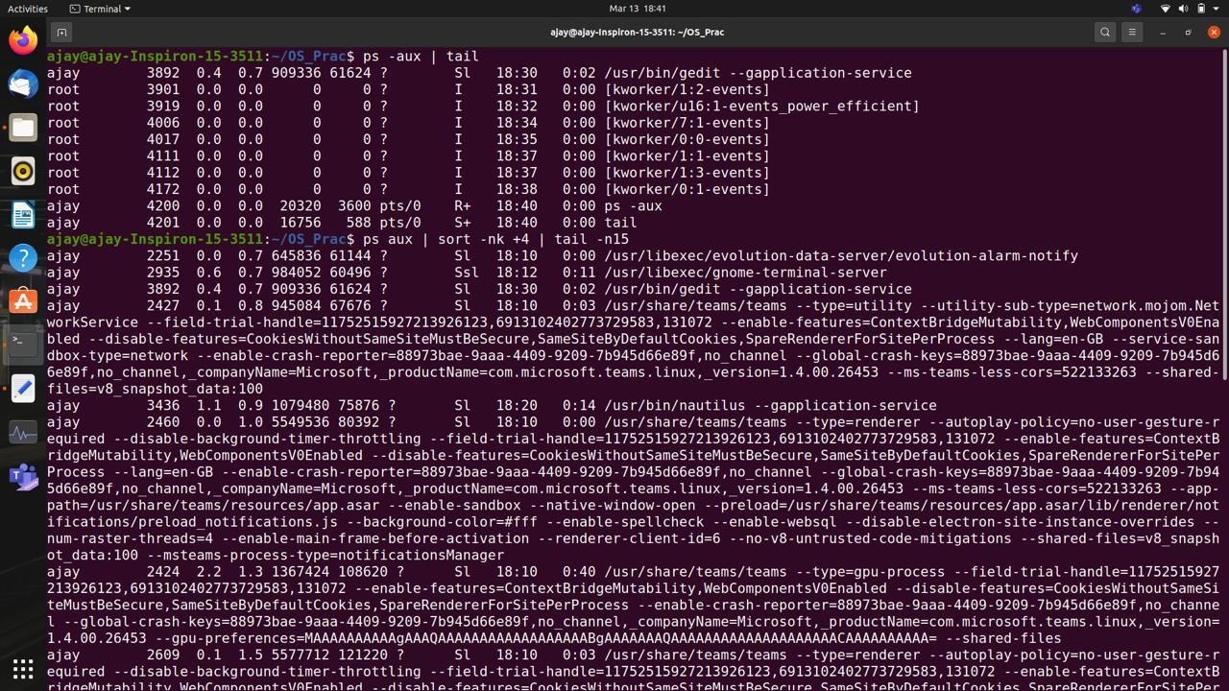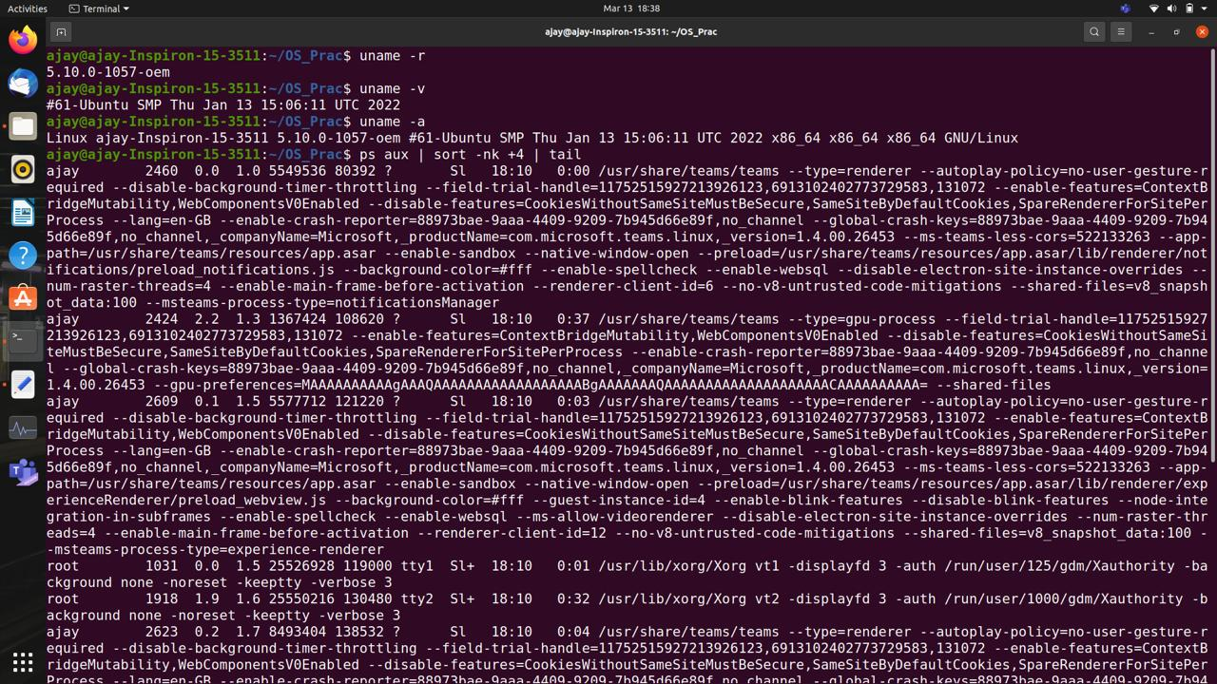

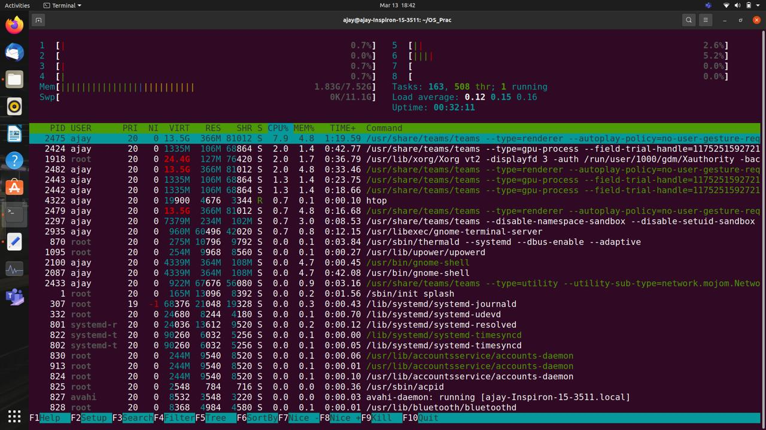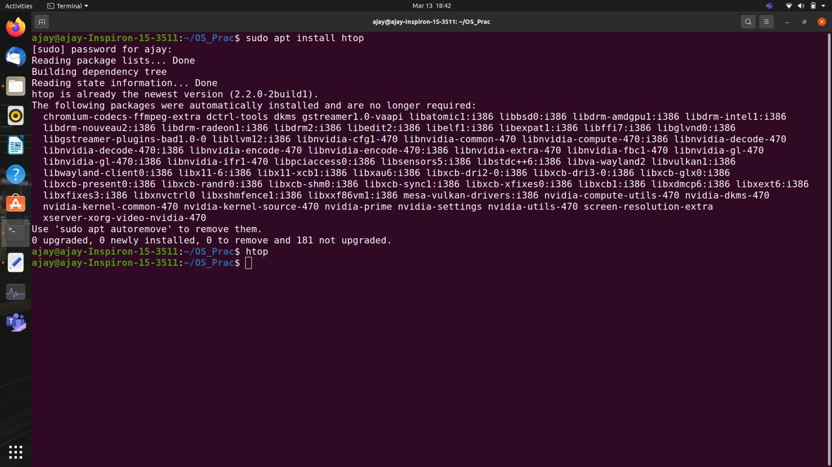

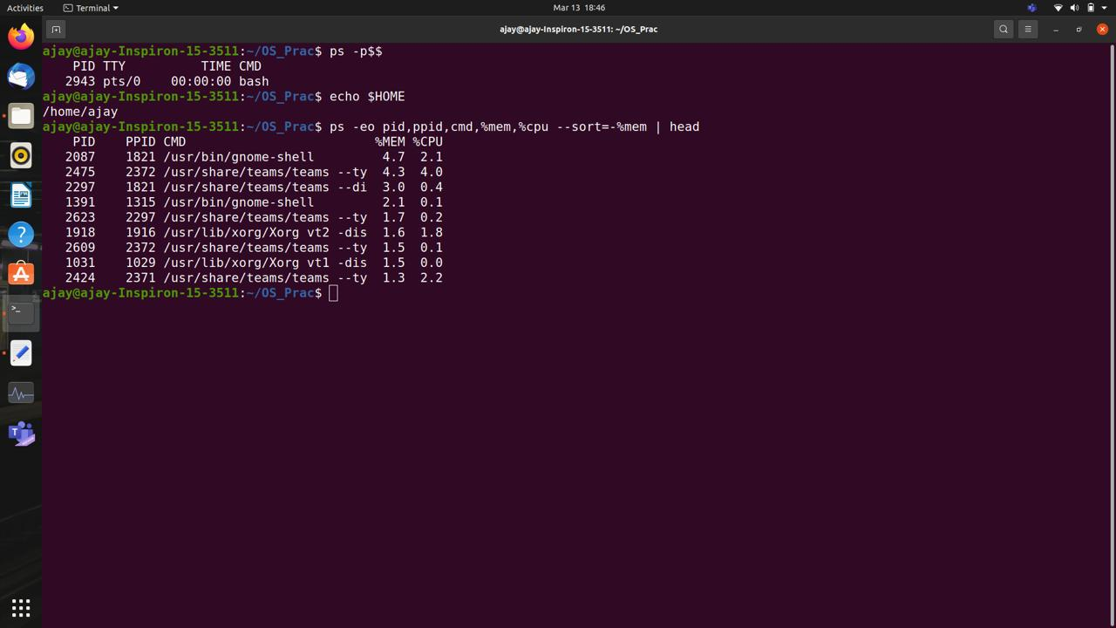

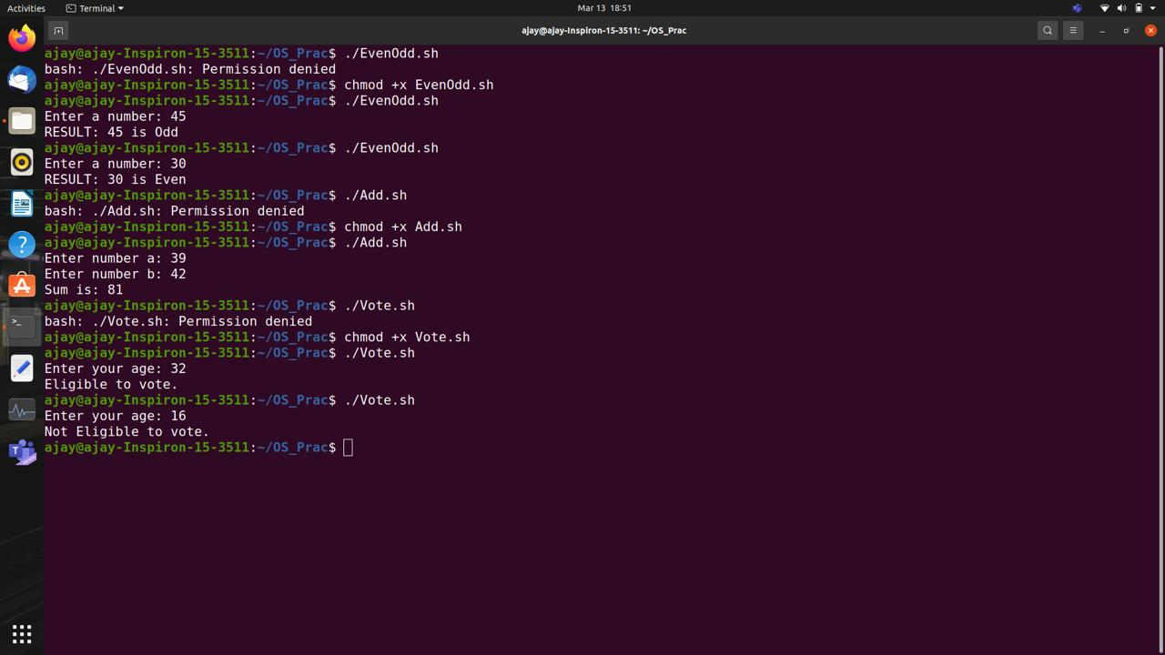

EXPERIMENT NO : 03

Aim: implement Basic Commands of Linux like ls, cp, mv using Kernal APIs

Theory:

cp → cp - r → copies the file

cp - backups → It copies the backups of the destination file in the source folder.

cp - i → It asks for confirmation of the user whether yes or no and gives warning to

the user before overriding the destination file.

cp-ie.txt b.txt

cp -f → Unable to open destination file for writing because the user has not allowed the writing operation .By writing the command, the destination file is deleted and the content is copied from source to destination.

cp - v → it is used for which command is running in backup.

cp - p → It preserves the attributes of files such as last date modification time, time of last access owners and the file permissions.

Syntax : cp-p source file destination file.

cp - l → To create a hand link file

mv → (move or rename).

mv.i → Ask the user for confirmation before moving the file.

mv - f → It provides the protection and overrides destination file forcefully and deletes the

source file.

mv - f a.txt b.txt

mv - n → It takes/prevents the existing file from being overridden.

mv - n a.txt b.txt

mv - b → To take the backup of an existing file.

Conclusion : Thus we have successfully studied and implemented various basic commands

of Linux like ls, cp and mv using kernel Apis

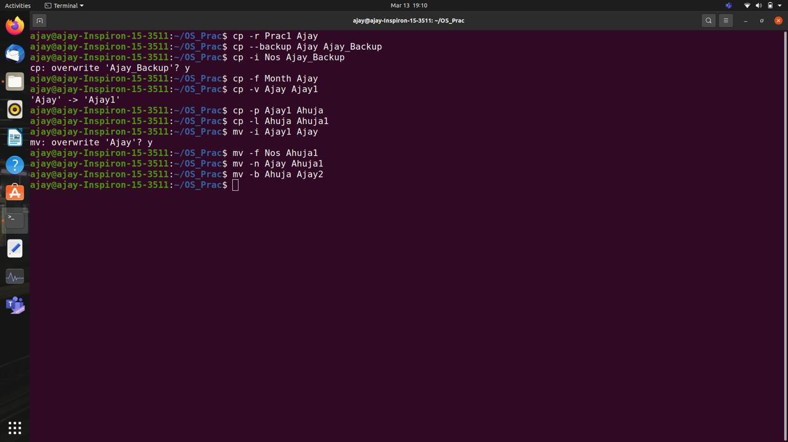

EXPERIMENT NO: 04

AIM : To create a child process in Linux using system calls; fork().

Theory :

1] System call

When a program is in user mode and requires access to Ram or hardware resources, it must ask the kernel to provide access to that resource. This is done via something called a system call. When a program makes a system call, the mode is switched from user mode to Kernel mode .This is called context switch. The kernel provides the resources which the program requested. System calls are made by user level programmes in following cases :

* Creating, opening, closing and delete files in the system
* Creating and managing new processes
* Creating a connection in the network, sending and receiving packets
* Requesting access to a hardware device like a mouse or a printer

2] Fork ( )

The fork system call is used to create processes. When a process makes a fork().call, an exact copy of the process is created.

There are now two processes, one being the parent process and the other being the child process. The process which called fork()call is the parent process and the process which is created newly is called child process. The child process will be exactly the same as the parent. The process state of the parent i.e the address space, variables, open files etc is copied into the child process. The change of values in the parent process doesn’t affect the child and vice versa.

Conclusion: Hence we implemented and studied how to create child process in Linux using

for system calls

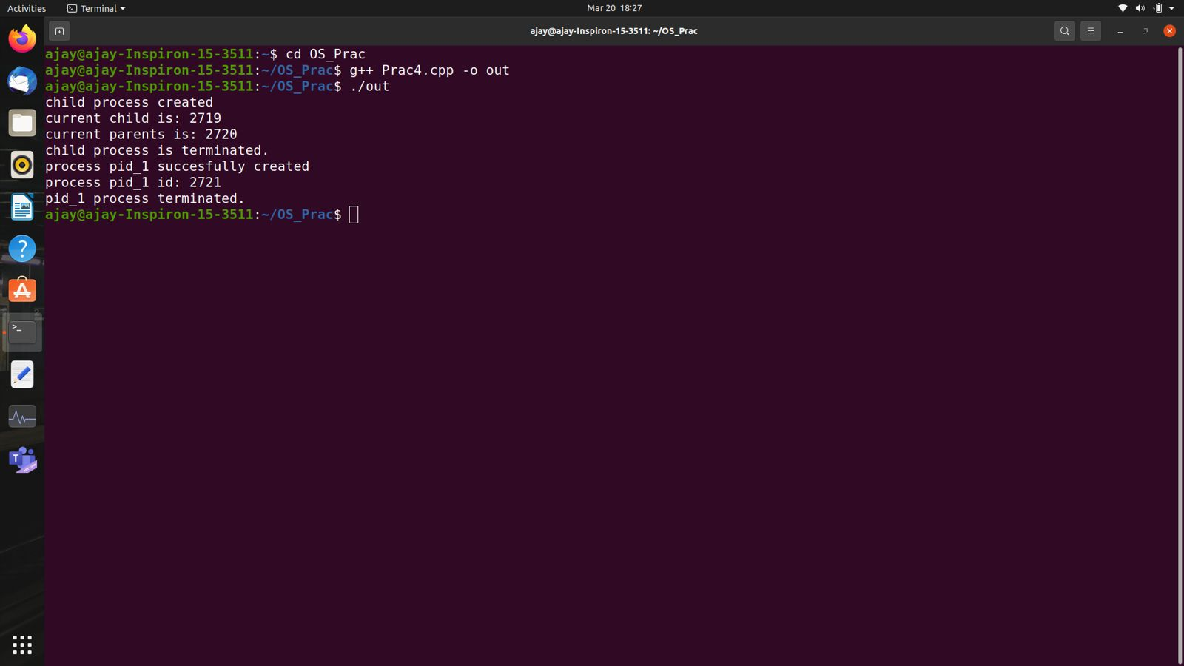

#include <iostream>

#include<sys/wait.h>

#include<unistd.h>

using namespace std;

int wait_func()

{

int pid_1 = fork();

if(pid_1==0)

{

cout<<"process pid_1 succesfully created"<<"\n";

cout<<"process pid_1 id: "<< getpid()<<"\n";

exit(0);

}

waitpid(pid_1, NULL,0);

cout << "pid_1 process terminated."<<"\n";

return 0;

}

int main()

{

int pid=fork();

if(pid==0)

{

cout<<"child process created"<<"\n";

cout<<"current child is: "<<getppid()<<"\n";

cout<<"current parents is: "<<getpid()<<"\n";

exit(0);

}

wait(NULL);

cout<<"child process is terminated."<<"\n";

wait_func();

return 0;

}

EXPERIMENT NO : 05

AIM : a) To study and implement non schedule in preemptive algorithm

b) To study and implement preemptive scheduling algorithm SRTF

THEORY:

Non preemptive algorithm

1] FCFS : First Come First Serve

It is a non-preemptive scheduling algorithm and the criteria for this is the arrival time of the process CPU is allotted to the process that requires it first. Jobs arriving later are placed at the end of the queue.

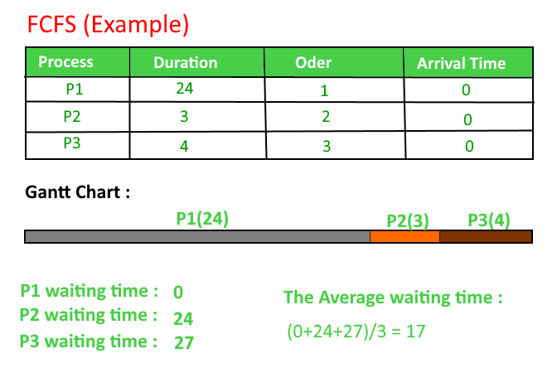

2] SJF : shortest job first

This is a non preemptive scheduling algorithm, which associates with each process, the length of the processes next CPU first.

Criteria : Burst Time.

This algorithm assigns processes according to BT if BT of two processes is the same we use FCFS scheduling criteria.

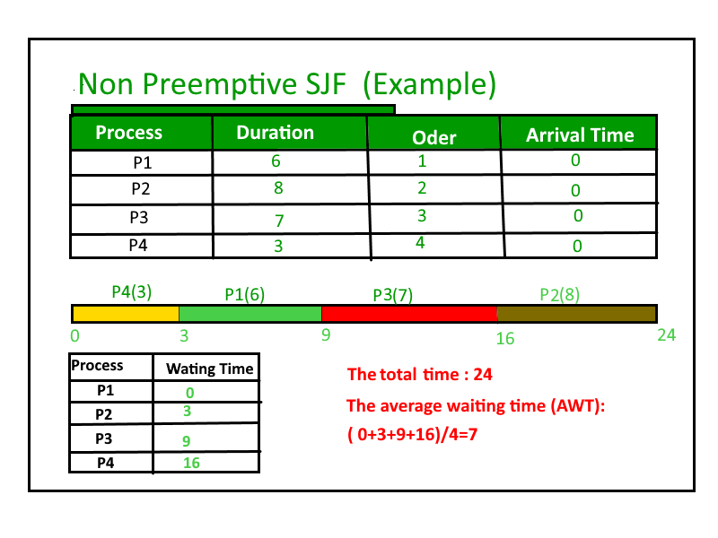

3] Priority Scheduling

This is a non preemptive scheduling algorithm. Each process here has a priority is either assigned already or externally done.

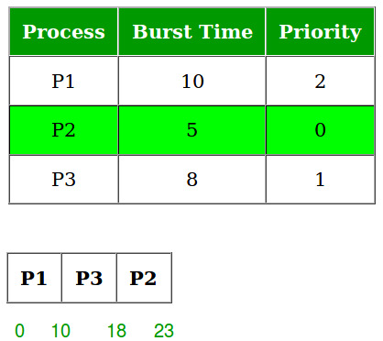

Preemptive Scheduling Algorithm : SRTF/STRN

Shortest Remaining Time First / Shortest Remaining Time Next scheduling.

It is a preemptive SJF Algorithm. The choice arrives when a new process arrives as the ready queue. While a previous process is still executing. The next CPU burst if the newly arrived process may be shorter than what is left of the currently executing process. A preemptive SJF with preempt the current executing process and not allow the currently running process to finish its CPU burst.

Round Robin is also one preemptive algorithm.

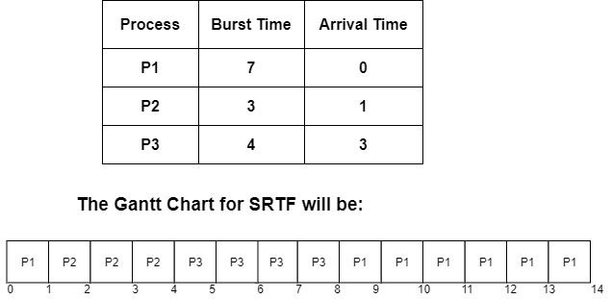

Conclusion : Thus we have successfully study done implemented scheduling algorithm

EXPERIMENT NO 6

AIM - To implement Critical Section Problem in Operating System

THEORY -

PROGRAM -

#include<stdio.h>

#include<unistd.h>

#include<semaphore.h>

#include<pthread.h>

sem_t mutexlock;

int value = 0;

void* producer()

{

sem_wait(&mutexlock);

printf("\nProducer allowed to enter critical section");

//CRITICAL SECTION

for(int i = 0; i<10 ; i++)

{

printf("\nvalue: %d",++value);

}

sem_post(&mutexlock);

printf("\nProducer has set semaphore...");

}

void* consumer()

{

sem_wait(&mutexlock);

printf("\nConsumer allowed to enter critical section");

//CRITICAL SECTION

for(int i = 0; i<10 ; i++)

{

printf("\nvalue: %d",value--);

}

sem_post(&mutexlock);

printf("\nConsumer has set semaphore...");

}

int main()

{

sem_init(&mutexlock,0,1);

pthread_t p1,p2;

pthread_create(&p1,NULL,&producer,NULL);

pthread_create(&p2,NULL,&consumer,NULL);

pthread_join(p1,NULL);

pthread_join(p2,NULL);

sem_destroy(&mutexlock);

return 0;

}

OUTPUT -

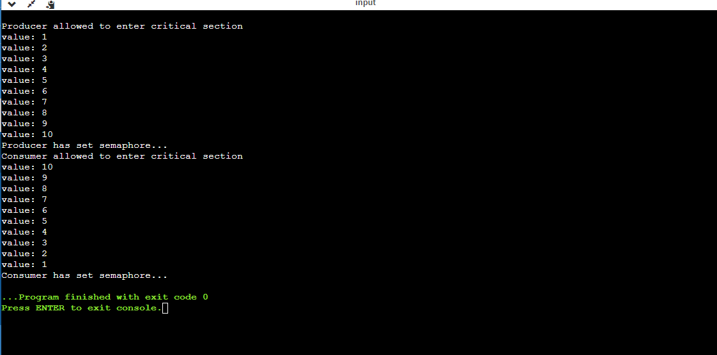

EXPERIMENT NO 7

AIM - a) To implement the Dining Philosopher Problem

- b) Write a Program to demonstrate concept of Deadlock avoidance through Bankers Algorithm

THEORY -

1. Dining Philosophers Problem - The Dining Philosopher Problem states that K philosophers are seated around a circular table with one chopstick between each pair of philosophers. There is one chopstick between each philosopher. A philosopher may eat if he can pickup the two chopsticks adjacent to him. One chopstick may be picked up by any one of its adjacent followers but not both.

There are three states of the philosopher: THINKING, HUNGRY, and EATING. Here there are two semaphores: Mutex and a semaphore array for the philosophers. Mutex is used such that no two philosophers may access the pickup or putdown at the same time. The array is used to control the behaviour of each philosopher. But, semaphores can result in deadlock due to programming errors

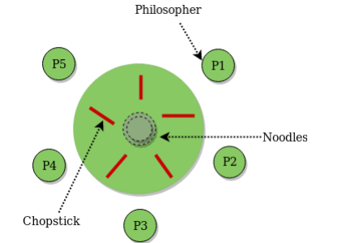

1. The banker’s determined maximum possible amount of all resources, then makes an “s-state” check to test for possible activities, before deciding whether allocation should be allowed to continue. Banker’s algorithm is named so because it is used in the banking system to check whether a loan can be sanctioned to a person or not. Suppose there are n number of account holders in a bank and the total sum of their money is S. If a person applies for a loan then the bank first subtracts the loan amount from the total money that bank has and if the remaining amount is greater than S then only the loan is sanctioned. It is done because if all the account holders come to withdraw their money then the bank can easily do it. In other words, the bank would never allocate its money in such a way that it can no longer satisfy the needs of all its customers. The bank would try to be in a safe state always.

Data structures used are as follows:

• n-Number of process, m-number of resource types.

• Available: Available[j]=k, k – instance of resource type Rj is available.

• Max: If max[i, j]=k, Pi may request at most k instances resource Rj.

• Allocation: If Allocation [i, j]=k, Pi allocated to k instances of resource Rj

• Need: If Need[I, j]=k, Pi may need k more instances of resource type Rj

Safety Algorithm

1. Work and Finish be the vector of length m and n respectively, Work=Available and Finish[i] =False. 2. Find an i such that both

• Finish[i] =False

• Need<=Work If no such I exists go to step

1. work=work+Allocation, Finish[i] =True;

2. if Finish[1]=True for all I, then the system is in safe state.

Resource request algorithm Let Request i be a request vector for the process Pi, If request i=[j]=k, then process Pi wants k instances of resource type Rj.

1. if Request<=Need I go to step 2. Otherwise raise an error condition.

2. if Request<=Available go to step 3. Otherwise Pi must since the resources are available.

3. Have the system pretend to have allocated the requested resources to process Pi by modifying the state as follows;

Available=Available-Request I;

Allocation I =Allocation+Request I;

Need i=Need i-Request I;

If the resulting resource allocation state is safe, the transaction is completed and process Pi is allocated its resources. However if the state is unsafe, the Pi must wait for Request i and the old resource-allocation state is restored.

Algorithm:

1. Start the program.

2. Get the values of resources and processes.

3. Get the avail value.

4. After allocation, find the needed value.

5. Check whether it is possible to allocate.

6. If it is possible then the system is in safe state.

7. The Other system is not in a safe state.

8. If the new request comes then check that the system is in safety or not to grant the request

9. Stop the Program

PROGRAM -

**Deadlock Avoidance** -

#include<stdio.h>

#include<conio.h>

struct da

{

int max[10],a1[10],need[10],before[10],after[10];

}p[10];

void main()

{

int i,j,k,l,r,n,tot[10],av[10],cn=0,cz=0,temp=0,c=0;

clrscr();

printf("\n ENTER THE NO. OF PROCESSES:");

scanf("%d",&n);

printf("\n ENTER THE NO. OF RESOURCES:");

scanf("%d",&r);

for(i=0;i<n;i++)

{

printf("PROCESS %d \n",i+1);

for(j=0;j<r;j++)

{

printf("MAXIMUM VALUE FOR RESOURCE %d:",j+1);

scanf("%d",&p[i].max[j]);

}

for(j=0;j<r;j++)

{

printf("ALLOCATED FROM RESOURCE %d:",j+1);

scanf("%d",&p[i].a1[j]);

p[i].need[j]=p[i].max[j]-p[i].a1[j];

}

}

for(i=0;i<r;i++)

{

printf("ENTER TOTAL VALUE OF RESOURCE %d:",i+1);

scanf("%d",&tot[i]);

}

for(i=0;i<r;i++)

{

for(j=0;j<n;j++)

temp=temp+p[j].a1[i];

av[i]=tot[i]-temp;

temp=0;

}

printf("\n\t RESOURCES ALLOCATED NEEDED TOTAL AVAIL");

for(i=0;i<n;i++)

{

printf("\n P%d \t",i+1);

for(j=0;j<r;j++)

printf("%d",p[i].max[j]);

printf("\t");

for(j=0;j<r;j++)

printf("%d",p[i].a1[j]);

printf("\t");

for(j=0;j<r;j++)

printf("%d",p[i].need[j]);

printf("\t");

for(j=0;j<r;j++)

{

if(i==0)

printf("%d",tot[j]);

}

printf(" ");

for(j=0;j<r;j++)

{

if(i==0)

printf("%d",av[j]);

}

}

printf("\n\n\t AVAIL BEFORE\T AVAIL AFTER ");

for(l=0;l<n;l++)

{

for(i=0;i<n;i++)

{

for(j=0;j<r;j++)

{

if(p[i].need[j] >av[j])

cn++;

if(p[i].max[j]==0)

cz++;

}

if(cn==0 && cz!=r)

{

for(j=0;j<r;j++)

{

p[i].before[j]=av[j]-p[i].need[j];

p[i].after[j]=p[i].before[j]+p[i].max[j];

av[j]=p[i].after[j];

p[i].max[j]=0;

}

printf("\n P %d \t",i+1);

for(j=0;j<r;j++)

printf("%d",p[i].before[j]);

printf("\t");

for(j=0;j<r;j++)

printf("%d",p[i].after[j]);

cn=0;

cz=0;

c++;

break;

}

else

{

cn=0;cz=0;

}

}

}

if(c==n)

printf("\n THE ABOVE SEQUENCE IS A SAFE SEQUENCE");

else

printf("\n DEADLOCK OCCURED");

getch();

}

OUTPUT -

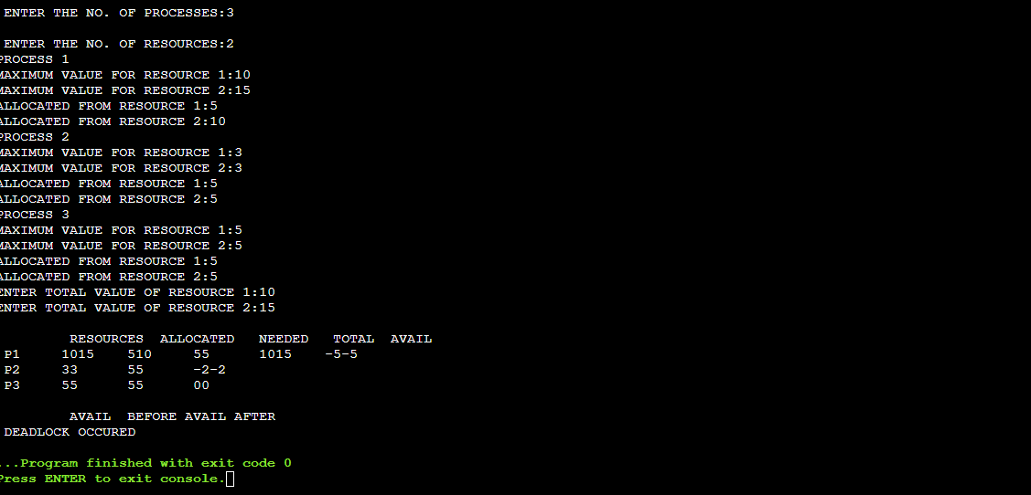

**Dining Philosopher -**

#include <pthread.h>

#include <semaphore.h>

#include <stdio.h>

#define N 5

#define THINKING 2

#define HUNGRY 1

#define EATING 0

#define LEFT (phnum + 4) % N

#define RIGHT (phnum + 1) % N

int state[N];

int phil[N] = { 0, 1, 2, 3, 4 };

sem_t mutex;

sem_t S[N];

void test(int phnum)

{

if (state[phnum] == HUNGRY

&& state[LEFT] != EATING

&& state[RIGHT] != EATING) {

// state that eating

state[phnum] = EATING;

sleep(2);

printf("Philosopher %d takes fork %d and %d\n",

phnum + 1, LEFT + 1, phnum + 1);

printf("Philosopher %d is Eating\n", phnum + 1);

sem_post(&S[phnum]);

}

}

void take_fork(int phnum)

{

sem_wait(&mutex);

state[phnum] = HUNGRY;

printf("Philosopher %d is Hungry\n", phnum + 1);

test(phnum);

sem_post(&mutex);

sem_wait(&S[phnum]);

sleep(1);

}

void put_fork(int phnum)

{

sem_wait(&mutex);

state[phnum] = THINKING;

printf("Philosopher %d putting fork %d and %d down\n",

phnum + 1, LEFT + 1, phnum + 1);

printf("Philosopher %d is thinking\n", phnum + 1);

test(LEFT);

test(RIGHT);

sem_post(&mutex);

}

void* philosopher(void* num)

{

while (1) {

int* i = num;

sleep(1);

take_fork(*i);

sleep(0);

put_fork(*i);

}

}

int main()

{

int i;

pthread_t thread_id[N];

sem_init(&mutex, 0, 1);

for (i = 0; i < N; i++)

sem_init(&S[i], 0, 0);

for (i = 0; i < N; i++) {

pthread_create(&thread_id[i], NULL,

philosopher, &phil[i]);

printf("Philosopher %d is thinking\n", i + 1);

}

for (i = 0; i < N; i++)

pthread_join(thread_id[i], NULL);

}

OUTPUT - 